Gabrielle F. Stephens

Education

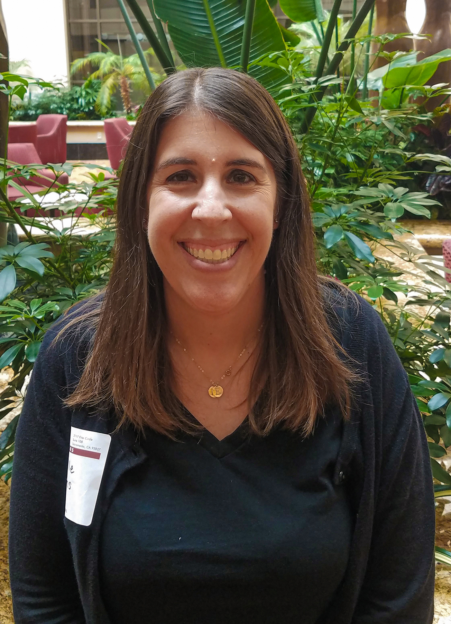Gabrielle Stephens

BS – Biology, University of California, Los Angeles, 2002

Professional Experience

Ms. Stephens has 20 years of experience in environmental consulting, all with SCS. As an SCS Project Director, she has been involved in numerous projects related to air permitting and compliance with solid waste regulations, including landfill gas (LFG) surface and perimeter monitoring, LFG assessment, and perimeter probe design and installation. She has provided air permitting services for LFG collection and control devices and associated equipment, including enclosed ground flares, LFG-to-energy (LFGTE) plants, and carbon absorption systems. She has also been involved in numerous projects related to air permitting and compliance for combustion equipment, including flares, engines, and turbines.

Ms. Stephens has worked with many of the air districts in California, including the South Coast Air Quality Management District (SCAQMD), Bay Area Air Quality Management District (AQMD), Antelope Valley Air Quality Management District (AQMD), Mojave Desert Air Quality Management District (AQMD), San Joaquin Valley Air Pollution Control District (SJVAPCD), Ventura County Air Pollution Control District (APCD), Santa Barbara Air Pollution Control District (APCD), Imperial County Air Pollution Control District (APCD), and San Diego County Air Pollution Control District (APCD). She has also worked with Local Enforcement Agencies (LEAs) across Southern California and air districts in Oregon, Arizona, and Nevada.

Ms. Stephens has completed emissions estimates and inventories and has prepared numerous permit-to-construct/operate and Title V permit applications. She prepares compliance reports, which includes reviewing and maintaining records and regulatory deadlines. She has also completed evaluations and reporting for the federal Greenhouse Gas (GHG) Rule and Rule AB 32 Landfill Methane Rule (LMR).

Notable projects that Ms. Stephens has been involved in are described below.

Air Permitting Services for LFG Collection and Control Devices and Associated Equipment, CA. Ms. Stephens provided environmental services for numerous sites that contained enclosed ground flares, LFGTE plants, and carbon absorption systems. Permitting services included air dispersion modeling, health risk assessments (HRAs), emissions off-set calculations, and regulatory negotiation. The projects Ms. Stephens was involved with included new LFGTE permitting for Frank R. Bowerman (FRB) Landfill, Lockwood Landfill, Riverbend Landfill, Columbia Ridge Landfill and Recycling Center, and Landfill, as well as modifications for Bradley Landfill and Recycling Center, Lancaster Landfill and Recycling Center, Chiquita Canyon Landfill, and West Miramar Landfill. Ms. Stephens has also prepared numerous flare permit applications for sites including FRB Landfill, Lockwood Landfill, Chiquita Canyon Landfill, and multiple County of San Diego landfills.

Regulatory Compliance Audits, Facility Permitting, and Regulatory Interface with Local, State, and Federal Agencies. Ms. Stephens provided environmental services to ensure compliance with all applicable rules and environmental regulations.

Preparation of Compliance Reports, CA. Ms. Stephens prepared compliance reports for sites including Mid-Valley, Victorville, San Timoteo, Milliken, and Colton Sanitary Landfills, Toland Road, Oxnard, and Santa Maria Regional Landfill in Southern California, and Otay Sanitary, San Marcos, and Sycamore Sanitary Landfills in San Diego.

Compliance Support. Ms. Stephens provided compliance support for landfill sites including Otay Sanitary Landfill, San Marcos Landfill, Sycamore Landfill, Allied Imperial Landfill, Santa Maria Regional Landfill, Apex Regional Landfill, Miramar Landfills, and 12 County of San Bernardino Landfills. She has also provided compliance support for industrial sites including Sanger Boats, MB Sports, and Maruhachi Ceramics of America.

Title V and New Source Review (NSR) and Prevention of Significant Deterioration (PSD) Services. Ms. Stephens assisted in the preparation of Title V and NSR/PSD permit applications and documentation for landfill sites, including a new landfill in Arizona.

Air Quality Impact Analysis and Permitting, Manteca, CA. Ms. Stephens provided environmental services associated with the proposed merging of two landfills located in Manteca, CA. Project activities included air emissions estimates from landfill surfaces and control devices, calculation of vehicle emissions rates using mathematical models, and estimation of PM10 emissions from stationary and mobile sources.

Annual GHG Reporting, CA. Ms. .Stephens prepared and submitted GHG federal mandatory reports and Annual AB 32 LMR Reports for Mid-Valley, Colton, San Timoteo, and Santa Maria Regional Landfills in Southern California, and San Marcos, South Chollas, and West Miramar Landfills in San Diego.

Completion of Emissions Estimates and Inventories, CA. Ms. Stephens conducted emissions estimates and inventories for sites including Altamont, Ox Mountain, and Mountain View Landfills in the Bay Area, Lancaster Landfill and Recycling Center, Antelope Valley Landfill and Disposal Facility, and six County of San Bernardino Landfills in Southern California, Sanger Boats and MB Sports in Central California, and San Marcos Landfill in San Diego.

Preparation of Permit-to-Construct/Operate Permit Application, CA. Ms. Stephens prepared the permit-to-construct and operate permit applications for sites including FRB Landfill, Lancaster Landfill and Recycling Center, and Chiquita Canyon Landfills in Southern California, West Contra Costa Sanitary Landfill and Potrero Hills Landfill in the Bay Area, Sycamore Sanitary, Otay Sanitary, Hillsborough, and Bell Jr. HS Landfills in San Diego, and Forward/Austin Road and Simi Valley Landfills in the San Joaquin Valley. Additional applications were prepared for projects in Oregon, Nevada, and Arizona.

Start-up, Shutdown, and Malfunction (SSM) Plans, CA. Ms. Stephens assisted in the preparation of SSM plans for Bradley and El Sobrante Landfills in Southern California.

NSPS Tier II LFG Sampling, Analysis, and Reporting, CA. Ms. Stephens provided environmental services for a landfill site located in Kern County, CA, in accordance with federal New Source Performance Standards (NSPS) regulations.

Indoor Air Methane Monitoring, Monterey Park, CA. Ms. Stephens provided environmental services at a former correctional facility in Monterey Park, CA.

Determination of LFG Generation Rates. Ms. Stephens determined LFG generation rates by utilizing computer models with input data from operator waste receipt records and decomposition data developed by SCS.

Installation, Monitoring, and Sampling of Well Systems. Ms. Stephens provided environmental services to determine surface infiltration rates and the presence and nature of subsurface contaminants in groundwater.